# Code No. 2059

## FACULTY OF ENGINEERING

**B.E. 4/4 (EEE) I-Semester (Main) Examination, November / December 2012**

**Subject : Power System Operation and Control**

**Time : 3 Hours Max. Marks: 75**

***Note:*** *Answer* ***all*** *questions of Part - A and answer any* ***five*** *questions from Part-B.*

**PART – A** (25 Marks)

1. List out the assumptions made in FDLF method. (2)

2. For the system show in figure 1 find Y-Bus? (3)

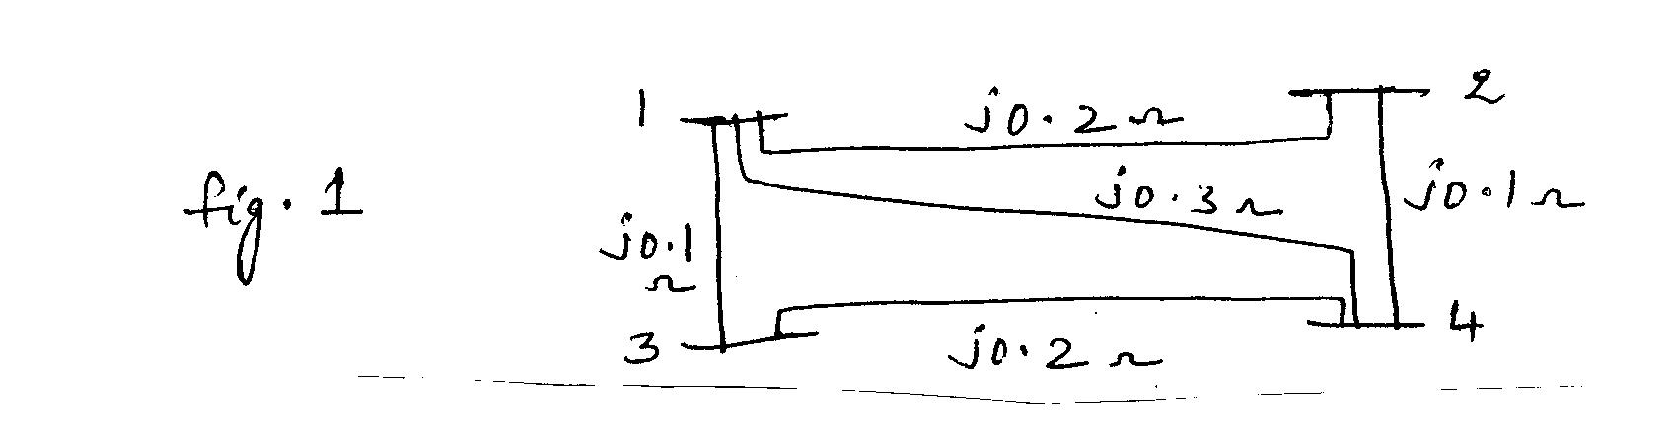

3. The incremental fuel costs in Rs/MWh of two generating plants are given as (3)



The system is operating on economic dispatch with P1=P2 =500 MW and . Find the penally factor of plant 2.

4. Define the terms : (i) Incremental fuel rate (ii) Incremental efficiency (2)

5. What is flat-frequency control? How is different from flat-tie line frequency control? (2)

6. How PV buses are handled in G-s method? (2)

7. Define: (i) Steady state stability (ii) Transient stability (2)

8. A 50 Hz, four pole turbo generator rated 100 MVA, 11KV has an inertia constant of 10 MJ/MVA. Find the stored energy in the rotor at synchronous speed. (2)

9. Explain the AVR with neat diagram. (3)

10. Draw and explain the operation of STATCOM. (3)

..2

Code No. 2059

..2..

**PART – B (5x10=50 Marks)**

11.(a) List the various data required for the formulation of a load flow problem and hence formulated voltage equations for a general 'n' bus power system. (3)

(b) For the system shown in figure 2 use Gauss-Seidel method and obtain voltages buses (2) and (3) at the end of the first iteration? (7)

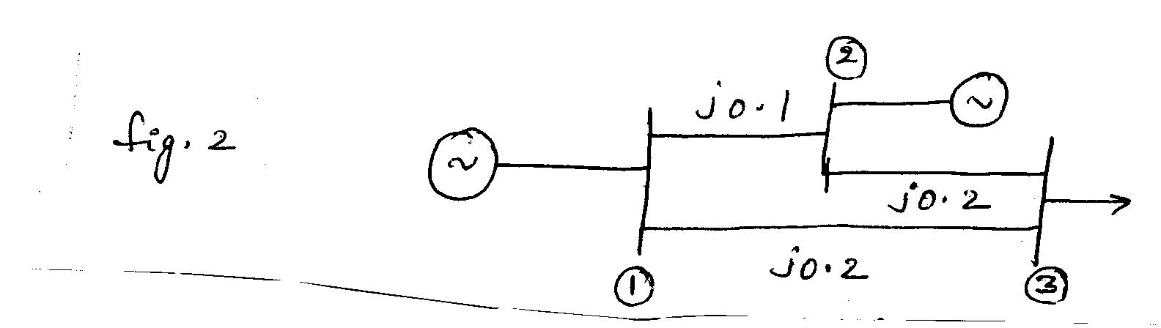

The line impedances marked in the figure are in p.u.

|  |  |  |  |  |  |  |  |  |
| --- | --- | --- | --- | --- | --- | --- | --- | --- |
| Bus No | Generation | | Load | | Voltage  |V| | Reactive power limit | | Remarks |
| P | Q | P | Q |  | Qmin | Qmax |  |
| 1  2  3 | -  5.32  - | -  -  - | -  -  3.64 | -  -  0.53 | 1.0  1.1  - | -  0  - | -  5.32  - | slack  PV  PQ |

12.(a) Derive the necessary condition for economic operation of n-plants considering transmission losses. (5)

1. The incremental fuel costs of two units are (5)

; 

Determine the economic load allocation between the units when the total load on the system is 160 Mw. C is in Rs/hr and P is in MW.

13.(a) What is single area system? Deduce dynamic models for a single area

system. Show the full block diagram. (6)

(b) Two generators rated 200 MW and 400 MW are operated in parallel. The drop characteristics of their generators are 4% and 5 % respectively from no load to full load. Determine the load shared by each unit for a load of 500 MW. (4)

..3

Code No. 2059

..3..

14.(a) Using equal area criterion, derive an expression for critical clearing angle for a system having a generator feeding a large system through double circuit line. (4)

(b) For the system show in figure 3, the generator has a rating of 50 MVA and H=2.7 mJ/MVA at rated speed. E=1.05, V=1, X1d=0.2, X1=X2=0.4 pu. The generator is supplying 50 MW to the infinite bus when a 3-phase fault occurs at the middle of the line 2. Plot the swing curve for a sustained fault upto a time of 0.5 sec Δ t = 0.05 sec.

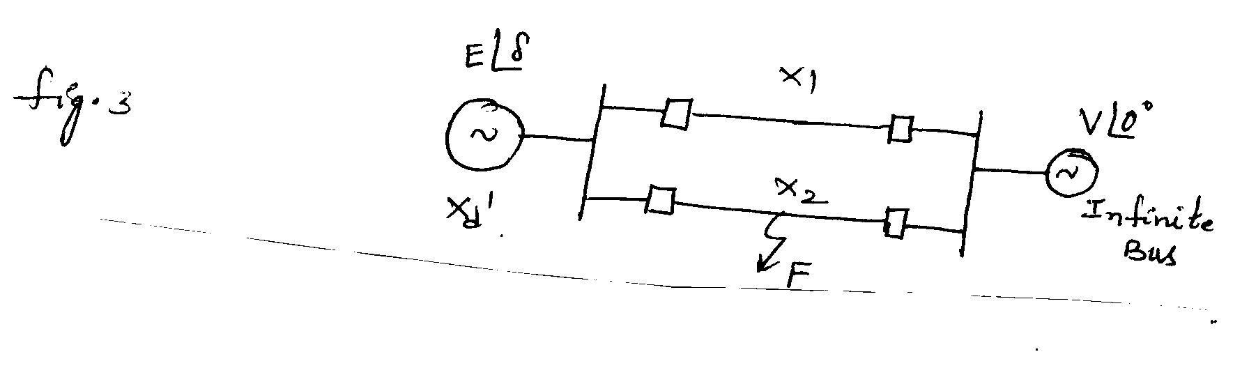

Figure 3

15.(a) Explain the reactive power generation by synchronous generators. (5)

(b) What are the basic FACTS controllers and with neat diagram explain the working of UPFC? (5)

16.(a) Distinguish between rotor angle stability and voltage stability. (4)

(b) A 3-phase over head transmission line in which voltages at both ends are kept fixed at 66 kV has a negligible resistance and an inductive reactance of 20 ohms / conductor. What is the maximum power that could be transmitted over this line. If this line when working at 60% of the above steady state limit suffers a short circuit which is cleared soon after and circuit restored. What are the limits of angular oscillations for transient stability ? (6)

17. Write short notes on the following:

(a) Tie line bias control (3)

(b) Advantages and disadvantages of series compensation (3)

(c) Dynamic response of single area system (4)

******